MTB XCC/XCO Technical Guide
Kokkola MTB Weekend

8-9.7.2023
Köykärinmäki, Kokkola

Date 8 -9 / 7 / 2023
Event Location: Köykärinmäki Hiihtotie 7, 67400 Kokkola Finland
Organiser: Gamlakarleby IF Cycling mtb@gamlakarlebyif.fi
Jaakko Suomu jaakko.suomu@gamlakarlebyif.fi
Kaj Granberg kaj.granberg@gamlakarlebyif.fi

Short Course Race
Class of Event:
Saturday 8.7.2023 XCC C3: Elite Male/Female,
UCI Class 3 to be run under UCI Regulations. The UCI scale of penalties apply.
Supporting Events: U9, U11, U13, U15, U17, Junior (U19), Veteran Men/Women
Finland National to be run under Cycling Finland (Suome Pyöräily) Regulations.
https://pyoraily.fi/wp-content/uploads/20230108_osa4-2023_MAASTO.pdf

Prize List:
Minimum prize values in the Elite Men’s, Elite Women’s, Junior Men’s and Junior Women’s races are determined By the UCI financial obligations, based upon a Euro exchange rate established by the UCI at the beginning of the year.
URL of UCI Financial regulations https://assets.ctfassets.net/761l7gh5x5an/1uTVhAMkkwuZQkIhnpbteP/9992cdc649e2e79d44fbc9bf836286ff/2023_UCI_MTB_Financial_Obligations_clean_publication.pdf
With a screen grab as below
 | Elite Men/Female
1 | 200 €
2 | 150 €
3 | 100 €
4 | 75 €
5 | 50 €

*Prize winners in the categories listed above will be contacted after the event to arrange a bank transfer. (if there is an email address if they feel they had no contact: mtb@gamlakarlebyif.fi)
Points Scale:
In accordance with the applicable UCI points scale for class 3 events:
Elite
1. | 2. | 3. | 4. | 5.
10 | 6 | 4 | 2 | 1

Cross Country Race XCO
Class of Event:
Sunday 9.7.2023 XCO C2:
Elite Men/Women
Junior Men/Women
UCI Class 2 to be run under UCI Regulations. The UCI scale of penalties apply.
Supporting Events: U9, U11, U13, U15, U17, Veteran Men/Women
FIN National to be run under Cycling Finland (Suomen Pyöräily) Regulations.
Can you put URL to these XCO regulations here

Prize List:
Minimum prize values in the Elite Men’s, Elite Women’s, Junior Men’s and Junior Women’s races are determined By the UCI financial obligations, based upon a Euro exchange rate established by the UCI at the begining of the year.

 | Elite Male /Female | Junior Male/Female
1 | 250 € | 80 €
2 | 200 € | 65 €
3 | 150 € | 50 €
4 | 125 € | 30 €
5 | 100 € | 25 €
6 | 90 €
7 | 80 €
8 | 75 €
9 | 60 €
10 | 50 €

*Prize winners in the categories listed above will be contacted after the event to arrange a bank transfer. (if there is an email address if they feel they had no contact: mtb@gamlakarlebyif.fi)

Points Scale:
In accordance with the applicable UCI points scale for class 2 events:
Elite
1. | 2. | 3. | 4. | 5. | 6. | 7. | 8. | 9. | 10.
30 | 20 | 15 | 12 | 10 | 8 | 6 | 4 | 2 | 1

Junior
1. | 2. | 3. | 4. | 5. | 6. | 7. | 8. | 9. | 10.
20 | 18 | 16 | 14 | 12 | 10 | 8 | 6 | 4 | 2

Preliminary race program
Saturday at 1 pm junior starts (U9-U15). A more detailed schedule when the number of participants is known. Elite starts at 3 pm at the earliest.
On Sunday, the first start at 10 a.m. (M/W U9, M/W U11, M/W U13, W U15)
Second start at 11 am
A more detailed schedule will become clear when the number of participants is known. Elite starts at 12 pm and 2 pm at the earliest-
Race HQ:
Adjacent to the carpark. ”kisakanslia” in ’Finnish’

Registration:
Advance entry only on-line for web site: https://my.raceresult.com/246305/registration
Sign-On, distribution of number boards, timing chips and technical zone passes at Race HQ.

Opening times:
Friday Saturday, Sunday
Registration for each race closes 30 minutes prior to the scheduled race start time.

Timekeeping:
Provided by PP Timing

Results:
Results can be found on the Gamlakarleby IF website after the event or on the PP timing website at https://my.raceresult.com/246305/results

Commissaires:
Commissaire President (PCP): appointed by UCI – Adrian Walls (GBR) awalls@me.com
Panel: appointed by Cycling Finland,
Jukka Kivirinta,
Björn Palm,
Hannu Autio,
Pekka Luhtala
- Registration procedure, accreditation, distribution of race numbers: location and times
- Description and detailed plan of the course indicating marshal location and medical points, length, profile and elevation of the course

Course/Location:
- *Course Practice is subject to change at short notice due to factors beyond our control.
- Prior to commencing training all entrants need register, collect and affix race number boards to their handlebars
- All competitors must enter the course at the designated point, where any last minute information can be relayed to you via a Commissaire or race official.
- ** The course is only open for practice during the times above. Riders seen on the course outside of the times will beasked to leave the course or face a DQ.

XCC Course
Lap Length 1.1 km
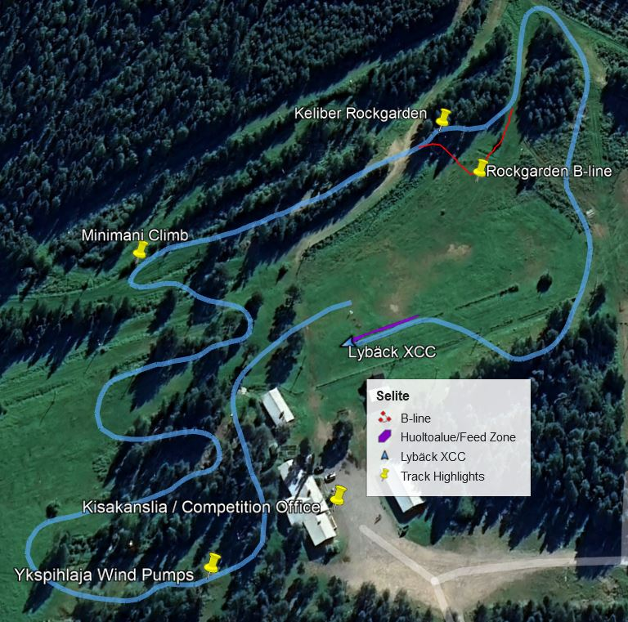

XCO Course
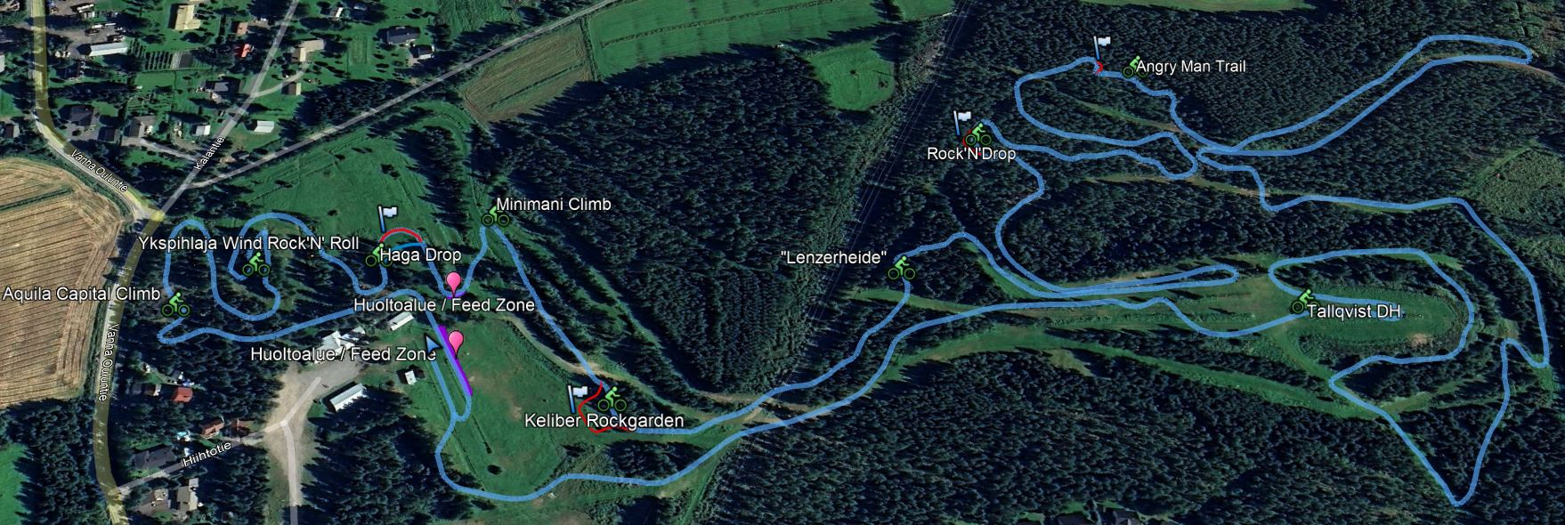
Lap Length 4,6 km. 150m climbing per lap
Larger track map on the website: www.gamlakarlebyif.fi
Rider information:
- Start and finish in the stadium area
- Parking and team areas marked
- Timing takes place via a chip on the number plate
- Award ceremony after the competition. Press conference in the awards area.
- Antidoping tests possibly after the competition by SUEK
- Feed/Technical Assistance Zones marked on the XCO track

Kokkola is located on the west coast of Finland about 500km / 6hr drive or 4hr train trip away from Helsinki. You can reach Helsinki by plane from anywhere in the world or by a ferry from Stockholm or Tallinn.
Kokkola-Pietarsaari Airport is located 20km outside of Kokkola. You can make a reservation for a taxi shuttle or rent a car at the airport.
There is also a ferry connection to Vaasa from Umeå, Sweden. From Vaasa it’s a 120km drive to Kokkola.

Nearest Hospital:
Soite , Mariankatu 16-20, 67100 Kokkola, 5 km

